2. Write a Python program to accept the user's first and last name and then getting them printed in the reverse order with a space between first name and last name
>>> def PrintReverse(fName,lName):
print(fName[-1::-1],lName[-1::-1])

>>> PrintReverse('Ashwini','Sawarkar')
iniwhsA rakrawaS
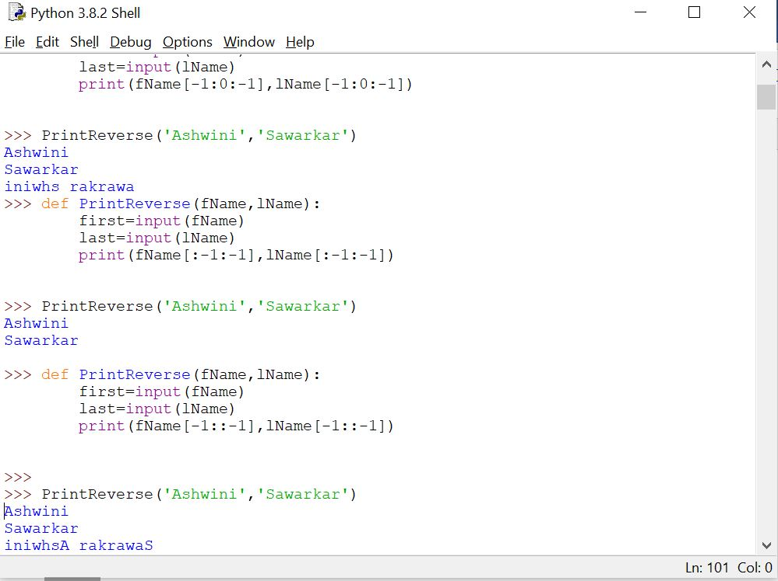

3. Write a Python program to find the volume of a sphere with diameter 12 cm
Formula: V=4/3 * π * r 3
Radius =12/2=6
>>> def VolumeOfSphere():
radius=12/2
volume=4/3*3.14*(radius**3)
print(volume)

>>> VolumeOfSphere()
904.3199999999999
>>>
